1. We used shell to interact with mongodb database. Shell is neutral ground which is independent of any programming languages.   
   But we know you would create some app with some programming language where you should be issuing these commands against mongodb server.
2. **Mongodb drivers**: These drivers are **packages** you **install** for **different programming languages** you app might be written in. These drivers are **bridges** b/w your programming language and the mongodb server.
3. In these drivers, you use the same commands we used in shell, just adjusted to the syntax of the language you’re working with of course.
4. 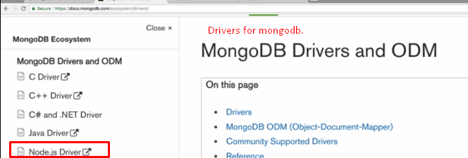
5. 